MOTHER’S FEAST
With Mary, daughters and mothers

On this journey of preparation for the celebration of such an important moment for our Institute, we are accompanied by the remembrance of some fundamental facts for the birth of our religious family and by Mary herself, who has always been our loving "Superior".
The itinerary we propose thus sees the reference to a key word for each charismatic place of the origins that recalls the presence of Mary:
1st Week (28 March – 3 April) CALL – TURIN “Take care of them, they are my daughters”
2nd Week (4 April – 10 April) IDENTITY – MORNESE “You are a living monument”
3rd Week (18 April – 24 April) ACCOMPANIMENT – NIZZA “Mary walks in this house”

Some resources are proposed below, taken from historical sources and biblical materials, which following the three areas outlined for this journey, can offer ideas to our communities to experience celebratory or formative moments in preparation for Mother's Feast.
Therefore, you will find:
- An historical cue riferring to our three charismatic places: Turin, Mornese, and Nizza.
- A biblical cue associated to the words “call”, “identity”, and “accompaniment”.
- Some proposals for commitment linked to an action to be accomplished by the community.

More specifically, below is the outline of what you will find for each week:
- Historical cue:
- Presentation Video
- Historical Source
- Comment

- Biblical cue:
- Images
- Presentation of the biblical figure
- Biblical Passage
- Prayer Refrain
- Psalm

- Commitment proposal:
- Proposal
- Material

In particular, the biblical cue invites us to meet the extraordinary humanity of three Old Testament women: Esther, Ruth and Deborah.
In these female figures of the Old Testament, among others, we can contemplate those traits that will be summarized and fully embodied by Mary. Through these prefigurations of her, Mary intervened in the history of Israel and of all humanity as she intervenes every day in ours, with a presence made of the same beauty, strength, and gentleness.
May the Virgin Mother, so present in the spirit of the great biblical women of the past, also impress her traits on the ‘disciples of today’, so that whoever sees her daughters may glimpse the resembling face of the mother.

Below is the summary table of the path we propose:

Key Word | Pope Francis  Word to the Chapter Members | Historical Cue | Biblical Cue | Commitment proposal
CALL | Heart in love | Turin 1862  “Take care of them, they are my daughters” | The call of  Esther | Angelus Prayer  Pay attention to today's calls.
IDENTITY | Heart of a Mother | Mornese 1872  “You are a living monument” | The identity  of Ruth | Sharing  Recount to each about our "being a living monument today".
ACCOMPANIMENT | A Heart that is close | Nizza 1885  “Mary walks in this house.” | The accompaniment of Deborah | Recount experiences  Accompanied by Mary to accompany the young people.

FIRST MOMENT: CALL “heart in love”
with the heart always in love with the Lord to welcome the thrusts of God's grace
(Pope Francis to the Capitulars)

- HISTORICAL CUE

HISTORICAL SOURCE

- From the “Cronistoria” (Volume I, pg. 24-25)

Approximately at this time (June 1862) the first occurrence of the repeated dream referred to by Fr. Francesia in his book on Mother Mazzarello seems to have been ascribed.
Without specifying the time, he says that Don Bosco had dreamed of being in Piazza Vittorio in Turin, among a large number of noisy girls who had begged him for help; of course, he had shielded himself from them. But then a noble Lady had appeared with her face all resplendent, and she had said to him, "Take care of them, they are my daughters.”

• From "Sr. Mary Mazzarello and the first two decades of the Daughters of Mary Help of Christians" by Fr. Francesia
Don Bosco told us how he had twice seen in a dream an extraordinary number of girls who were playing in Piazza Vittorio in Turin, and who were making a din and seemed abandoned to themselves. As soon as those girls saw him, they suspended their playing, and they all ran to meet him, shouting: Long live Don Bosco! and they begged him to take care of them.
Don Bosco told us, "I tried to distance myself from them, saying that I could not, that others would come to their help, because my mission was different. There was especially a crowd of older girls, who seemed strangers to such amusements. These addressed me in a more pitiful way, ‘As you can see,' they said, 'we are abandoned’! Then I saw a noble lady with a resplendent face appear, who with beautiful words encouraged me to satisfy their desire. And while she seemed to disappear from their midst, she repeated to me, 'Take care of them: they are my daughters!'."

COMMENT
Mary appears in Don Bosco's dreams as a "Woman of majestic aspect". The feature of her majestic and resplendent beauty is highlighted, which dazzles, fascinates, amazes, and consoles the one who contemplates her. It is above all the beauty of grace, of which she is full (cf. Lk 1:28). This beauty is not a privilege of the Virgin in the strict sense. In fact, even if she is certainly the first and the most beautiful, the Immaculate Conception, all the daughters and sons of God are called to participate in that same beauty, to become, that is, "holy and immaculate" in love (Eph 1:4).
Among the actions accomplished by Mary, there are some that express her maternal tenderness and her educational care: she smiles, looks with tenderness, consoles, encourages. Don Bosco will show particular resistance in the dream in which he will be invited to take care of girls. The girls beg him to help them; he would like to leave. Mary intervenes with her authoritative word, "Take care of them, they are my daughters!"

When the holy educator conceived the foundation of a female religious Institute, he condensed the feminine and Marian dimension of the educational work into an admirable synthesis. The FMA would work for the education of women by drawing inspiration from Mary, who associates her daughters in the same maternal mission as hers.

- BIBLICAL CUE

THE CALL OF ESTHER

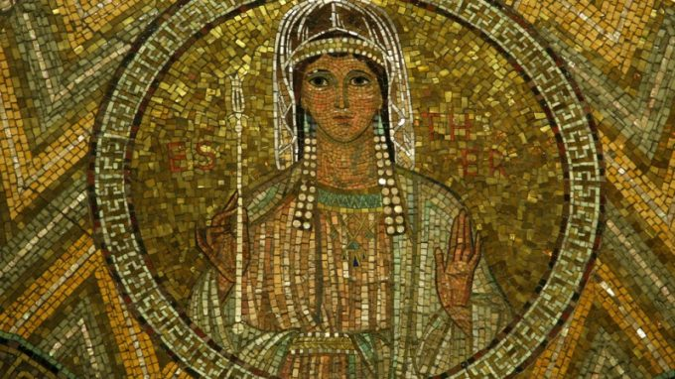
Queen Esther, wife of Ahasuerus, is the woman capable of entering into a relationship with God by manifesting full availability and an unshakable faith. Her first characteristic leads her to welcome in her life the call to take care of a portion of humanity (the entire people of Israel) by surrendering herself and putting her entire existence at the service of God's plan.
The second makes Esther's heart courageous and strong enough (for herself and for others) to open itself to intercessory prayer on behalf of all her people in need of relief and help.
Mosaic in the Basilica of the Dormition of Mary (Jerusalem)
From the Book of Esther (Greek text: 4: 17k-m; 4: 17r-t)
17k Queen Esther also sought refuge with the Lord, gripped by mortal anguish. She took off her luxurious clothes and put on her clothes of misery and mourning; instead of the superb perfumes she filled her head with ashes and trash. She humbled her body a lot and with her hair in disarray she moved where she was previously used to festive ornaments. She then she begged the Lord and said: 17l “My Lord, our king, you are the only one! Come my aid who am alone and I have no other help but you, because a great danger hangs over me. 17m I have heard from my birth, in the heart my family that you, Lord, have chosen Israel from all nations and our fathers from all their forefathers as your eternal inheritance, and have done to them according to what you promised. 17r Remember, Lord; manifest yourself in the day of our affliction and give me courage, o king of gods and ruler of all power. 17s Put in my mouth a well-measured word before the lion and turn his heart to hatred against him who fights us, to the extermination of him and of those who agree with him. 17t As for us, save us with your hand and come to my help, because I am alone and have no one but you, Lord!”

PRAYER REFRAIN

The Lord is my strength and I hope in Him.
The Lord is the Savior: in him I trust, I have no fear,
in him I trust, I have no fear.

Audio: the Lord (El Senyor) - YouTube

PSALM: CALLED FROM ETERNITY

PSALM 139 (138)
This psalm expresses the amazement and gratitude addressed to God who, with a gaze of love and care, watches over His creature who from and for all eternity is thought of, loved, and called.
You have searched me, Lord,
and you know me.
² You know when I sit and when I rise;
you perceive my thoughts from afar.
³ You discern my going out and my lying down;
you are familiar with all my ways.
⁴ Before a word is on my tongue
you, Lord, know it completely.
⁵ You hem me in behind and before,
and you lay your hand upon me.
⁶ Such knowledge is too wonderful for me,
too lofty for me to attain.
⁷ Where can I go from your Spirit?
Where can I flee from your presence?
⁸ If I go up to the heavens, you are there;
if I make my bed in the depths, you are there.
⁹ If I rise on the wings of the dawn,
if I settle on the far side of the sea,
¹⁰ even there your hand will guide me,
your right hand will hold me fast.
¹¹ If I say, “Surely the darkness will hide me
and the light become night around me,”
¹² even the darkness will not be dark to you;
the night will shine like the day,
for darkness is as light to you.
¹³ For you created my inmost being;
you knit me together in my mother’s womb.
¹⁴ I praise you because I am fearfully and wonderfully made;
your works are wonderful,
I know that full well.
¹⁵ My frame was not hidden from you
when I was made in the secret place,
when I was woven together in the depths of the earth.
¹⁶ Your eyes saw my unformed body;
all the days ordained for me were written in your book
before one of them came to be.
¹⁷ How precious to me are your thoughts, God!
How vast is the sum of them!
¹⁸ Were I to count them,
they would outnumber the grains of sand—
when I awake, I am still with you.
¹⁹ If only you, God, would slay the wicked!
Away from me, you who are bloodthirsty!
²⁰ They speak of you with evil intent;
your adversaries misuse your name.
²¹ Do I not hate those who hate you, Lord,
and abhor those who are in rebellion against you?
²² I have nothing but hatred for them;
I count them my enemies.
²³ Search me, God, and know my heart;
test me and know my anxious thoughts.
²⁴ See if there is any offensive way in me,
and lead me in the way everlasting.

- PROPOSAL FOR COMMITMENT

- During the day, live and meditate with greater awareness the Angelus Prayer:
- to grasp in depth the total availability of Mary to God,
- to be, like Her, available to accept the Lord's continuous and ever-new calls,
- to "renew the 'yes' to God in this time, as consecrated women and communities who allow themselves to be challenged by the Lord and by reality." (Pope Francis to the Capitulars)

- Print a CARD with the Angelus prayer to distribute to everyone and/or create a mini banner to be transmitted on whatsapp

SECOND MOMENT: IDENTITY “heart of a mother”
Heart of a mother, heart close, with compassion and tenderness.
(Pope Francis to the Capitulars)

- HISTORICAL CUE

HISTORICAL SOURCE

- From the “Cronistoria” (Volume I, pg. 305-306)

5 August 1872: Don Bosco speaks and gives the name to his ‘Monument’
Don Bosco, evidently moved, speaks. He tells of the importance of the completed act, he recalls the sanctity of the vows, the duties that they impose. He also mentions, albeit prudently, the discontent that may surround them, because all things of God have suffering as their seal; but he adds that this will benefit their sanctification, by making and keeping them truly humble. "Among the very small plants there is a very fragrant one, nard, often mentioned in Sacred Scripture. But do you know what it takes for the nard to give its good aroma? It must be well pounded. Do not regret, therefore, that you have to suffer. Whoever suffers for Jesus Christ will reign with Him forever.
You now belong to a Religious Family which belongs entirely to Our Lady; you are few, without means, and not supported by human approval. Let nothing disturb you. Things will change soon and you will have so many boarders that you will no longer know where to put them; and not only boarders, but also many postulants that you will find it hard to choose from among them.
Yes, I can assure you that the Institute will have a great future if you keep yourselves simple, poor, mortified. Therefore, observe all the duties of your new condition as religious, and helped by our tender Mother Mary Help of Christians, you will pass unharmed among the shoals of life and you will do great good to your souls and those of your neighbor.
Have as glory your beautiful title of Daughters of Mary Help of Christians, and often think that your Institute must be the living monument of Don Bosco's gratitude to the Great Mother of God, invoked under the title of Help of Christians.”

COMMENT
Throughout its history, the Institute will continually deepen its identity, horizons will broaden, and cultural contexts vary, but the symbol of the "living monument of gratitude to Mary Help of Christians" always remains an epiphany of the Institute's profound being, an all-encompassing and vital sign of the charismatic ideal of the Founder, a paradigm charged with spiritual dynamism and perennial novelty. The image of the ‘monument’ easily leads us to think of something static, passive, in need of being preserved and restored. Don Bosco, on the other hand, wants the monument erected by him to be 'alive', that is ‘dynamic, pervaded therefore by an interior tension of growth, by a vital force of development and expansion.’ How much trust and hope Don Bosco placed in the Institute and what mission he entrusted to it. Don Bosco wanted this 'monument' to be a living and growing reality, a force capable of transforming society into good, a movement with vast horizons, and a profound influence on history.
People of today are not sensitive to the image of the 'monument'. In a context in which the collection of fleeting impressions prevails, perceiving only short-lived emotions, agitated with worry closed in on the immediate, and living with shortness of breath, doesn't being a 'living monument' appear anachronistic?
And then in an era that exalts the self, the interests of the individual, doesn't talking about a 'monument of gratitude' sound almost like discord?
How to translate this 'symbol of identity' of the Institute today, facing challenges and wisely penetrating the different socio-cultures?
The task is arduous, but timelier than ever.
The Daughters of Mary Help of Christians know that the Institute is a "gift of the Holy Spirit", born with the direct intervention of Mary. Being a living monument of gratitude to Mary means prolonging Mary's maternal presence in the world, which is why the Daughters of Mary Help of Christians promise to live like her as 'helpers' especially among young women.
The renewed commitment to live the identity of a living monument of gratitude to Mary will be a significant tribute to this important anniversary of foundation.

- BIBLICAL CUE

THE IDENTITY OF RUTH

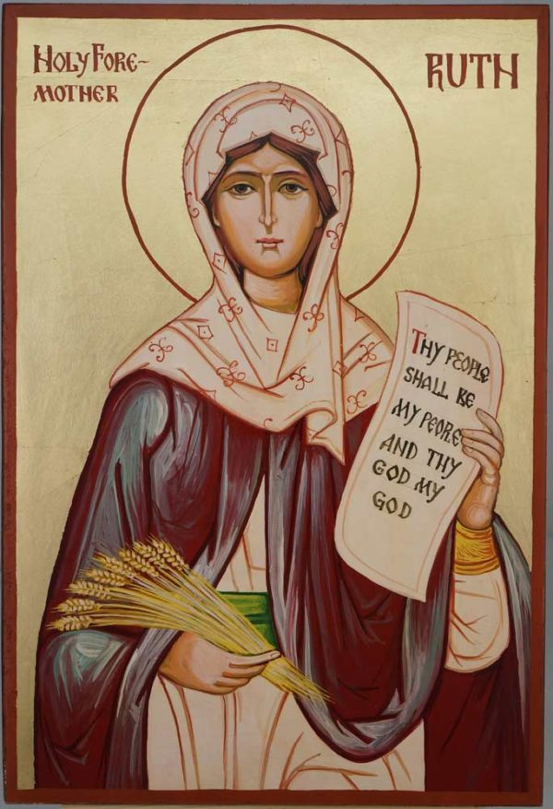
Ruth is the one who experiences in her history a very deep and articulated journey. Each stage collects what are the premises for her motherhood, which will be one of the most important generations in history that will make her an ancestor of David and therefore of Christ.
In order for her full identity to be structured, Ruth must be willing to make some 'cuts' that only a great and authentic love can require. Like a disciple, she leaves her homeland for an unknown land and, choosing to stay next to her mother-in-law Noemi, she declares her firm will of not wanting to lose the bond with her husband's mother in order to continue to be accompanied by her like a daughter, assisting her in return. Thus, Ruth will prepare to become a mother, nurturing her knowledge that she is her daughter.
Tenderness and goodness will be the characteristics of Ruth that will fascinate and conquer the heart of Boaz, who will find in the soul of this woman the solidity sought and expected to build his own family.
Icon of the Progenitor Ruth

From the Book of Ruth (2: 4-12)
Soon, along came Boaz from Bethlehem and said to the harvesters, “The Lord be with you,” and they replied, “The Lord bless you.” 5Boaz asked the young man overseeing his harvesters, “Whose young woman is this?” 6The young man overseeing the harvesters answered, “She is the young Moabite who came back with Naomi from the plateau of Moab. 7 She said, ‘I would like to gather the gleanings into sheaves after the harvesters.’ Ever since she came this morning she has remained here until now, with scarcely a moment’s rest.” 8Boaz then spoke to Ruth, “Listen, my daughter. Do not go to glean in anyone else’s field; you are not to leave here. Stay here with my young women. 9Watch to see which field is to be harvested, and follow them. Have I not commanded the young men to do you no harm? When you are thirsty, go and drink from the vessels the young people have filled.” 10Casting herself prostrate upon the ground, she said to him, “Why should I, a foreigner, be favored with your attention?” 11 Boaz answered her: “I have had a complete account of what you have done for your mother-in-law after your husband’s death; you have left your father and your mother and the land of your birth, and have come to a people whom previously you did not know. 12 May the Lord reward what you have done! May you receive a full reward from the Lord, the God of Israel, under whose wings you have come for refuge.”

PRAYER REFRAIN

God is love: dare to love without fear.
God is love: never fear.

Audio for the melody: Taizé - Bóg jest miłością - YouTube

PSALM: DAUGHTERS AND MOTHERS

PSALM 131 (130)
This very short and evocative psalm gives us one of the images most familiar to every culture and every age. Our soul can abandon itself with total trust in the arms of God who welcomes us with the same tenderness of a loving mother.

1Lord, my heart is not proud;
nor are my eyes haughty.
I do not busy myself with great matters,
with things too sublime for me.

2Rather, I have stilled my soul,
Like a weaned child to its mother,
Like a weaned child is my soul.
3Israel, hope in the Lord,
now and forever.

Video of the song of Fr. Domenico Machetta “I leave you peace” (attached)

- PROPOSAL FOR COMMITMENT

- SHARING in community:
- How do you live your being a living monument today, where you are inserted?
- Possibility of considering and contemplating the Institute's Coat of Arms: the spiritual meaning of the symbols reproduced in the coat of arms can help to better understand the identity of the FMA Institute and to create a more lively sense of belonging (http://www.salesian.online/archives/9022)
In which part of the Coat of Arms do you find yourself the most? Starting with the symbols of the coat of arms, what does the Lord call you to at this moment?
In which part of the arms do you feel the need to deepen your identity?
- The identity of the Institute of the Daughters of Mary Help of Christians: Cf. Constitutions articles 1-7 and “Characteristic traits of the FMA outlined by Don Bosco in the first Constitutions”.

- Materials can be used and adapted for "Good Nights"/"Good Mornings" to the community and young people at various levels.

THIRD MOMENT: ACCOMPANIMENT “a close heart”
God's style is always closeness.
(Pope Francis to the Capitulars)

- HISTORICAL CUE

HISTORICAL SOURCE

- From the “Cronistoria” (Volume V, pg. 42-45.47.51-52)

23 August 1885: “Our Lady walks this house and covers it with her mantle”

On 5 August 1885, Fr. Bonetti in Nizza on the occasion of the retreats for the ladies, wrote to Don Bosco who was in Mathi for health reasons, renewing his warm invitation, “The retreatants as much as the sisters ask to see Don Bosco at least in these days. So, if your health ever allows you to make this trip, I beg you in the name of all to come.” Unfortunately, Don Bosco's health conditions do not allow him the desired visit, as he himself wrote to Fr. Bonetti on 9 August, “New inconveniences that have come to me absolutely deprive me of the consolation of being able to find myself at the spiritual exercises in Nizza. You will make my apologies; I have prayed for them throughout the course of the same (…) Then give a special greeting to our beloved Sisters, to whom you will tell that if my health improves even a little, I will pay them a visit during their retreats because I have to communicate things of some importance to them.” For the feast of the Assumption, the sisters of the Retreat are already in the house, ready to begin the Spiritual Exercises the following day. In the hearts of all there is a question full of expectation: will Don Bosco come? The last lines of his letter written to Fr. Bonetti give wings to hope and make the desire for a paternal visit more alive, knowing that "he has things of some importance" to communicate.
Almost halfway through the Exercises, on 20 August, Fr. Bonetti, who absolutely does not want to renounce Don Bosco's visit, sends Fr. Bussi to bring him the new pressing invitation, "Allow a son to pray with great insistence and, if it were lawful for me, to command the father respectfully. I, who am on the spot, see not only useful, but almost necessary, for the S. V. to come to Nizza. There are three hundred sisters gathered here from all over for the Exercises, and in greater number precisely because of the well-founded hope and the promise made. May you come and do great good to each of them and to the whole Institute." The insistent prayer was not unfulfilled. On Saturday 22, around noon, Don Bosco arrived accompanied by Fr. Bussi. Who can tell of the joy of all in welcoming him? But also, the emotion in seeing him so exhausted and staggering that he can barely stand up.
Many cannot hold back their tears. The following morning, he presides over the function of vestition and profession. He receives the holy vows, blesses the medals and crucifixes, which he hands over to the novices and newly professed women. In the afternoon, Fr. Bonetti, warmly asked by the Mothers, accompanied Don Bosco to the small parlor, where they were waiting for him to have a special word, desired as a very particular grace of the Lord. A truly memorable meeting that the superiors then describe to us this way, thrilling us all. "When Don Bosco was among us, he said to us, 'Oh, then, you want me to tell you something, eh? Oh, if I could speak, how many things I would like to tell you! How many! But, as you can see, I am a weak old man, and I can hardly speak any more. But I want to tell you that Our Lady loves you very, very much and she is here among you!' The good father was moved; and then Fr. Bonetti, to help him, suggested,
- ‘Yes, so, so! Don Bosco means that Our Lady is your Mother and that she looks at you and protects you’.
- ‘No, no - Don Bosco went on - I mean that Our Lady is right here, in this house, that she is happy with you; and that if you continue in the spirit that currently reigns, and which is precisely what Our Lady desired ...’
Again, Don Bosco intervened more than before; and Fr. Bonetti took the word again to help him:
- ‘Yes, so, so! Don Bosco wants to tell you that if you are always good, Our Lady will be very happy with you.’

- ‘But no, but no,’ Don Bosco tried to explain, trying to control his emotion. ‘I want to tell you that Our Lady is truly here, here among you! Our Lady walks around this house and covers it with her mantle.’
And with the gesture of outstretched arms, and tear-filled eyes turned upward, he seemed to want us to understand that he really saw Our Lady going all through the house as in her own house, and the whole house was under the mantle of the Our Lady.”

COMMENT
These are the words that Don Bosco addressed to the FMA in his last meeting in Nizza Monferrato in 1885. Here by 'house' we mean the world, where the mission entrusted to the FMA and to the educating communities takes place. Everywhere Mary is present as protector, guide, and inspiration in helping us to live the generative power of the charism in the today of history. "Mary walks with us" is not an abstract phrase, but a reality that evokes a "vision", a certainty, rooted in faith and in the Salesian charism, a lived experience. From the beginning of the Gospel, we find Mary who, from Nazareth walks with solicitude towards Ain Karim to be a caring presence alongside Elizabeth, a sign of God's foreseeing grace. Without delay, she leaves her home to bring the good news of joy: Jesus. The enterprising style of Mary is confirmed at the wedding at Cana; without being asked, she perceives a need and takes the first step that anticipates the hour of the Son. With the intuition of a mother, she involves the servants and disciples in the journey of faith and ensures the joy of the feast. Her presence increases the happiness of the young newlyweds and she contributes to constituting the community of Jesus' disciples.

- BIBLICAL CUE

THE ACCOMPANIMENT OF DEBORAH
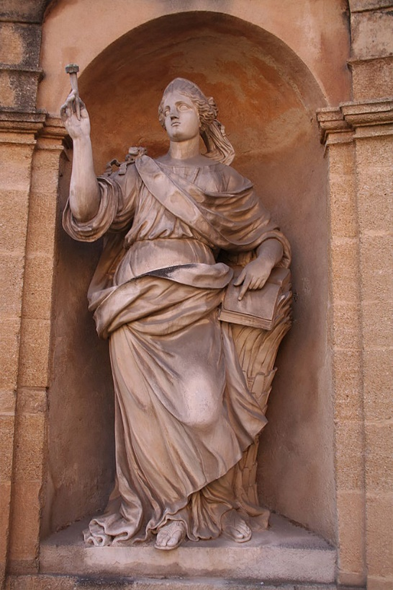
Deborah is one of the judges of Israel in the Old Testament. These figures, filled with special gifts from God, had the task of freeing the people from enemies and of advising the Jewish military leaders to obtain victory and salvation. The wisdom that God gives to Deborah through the gift of prophecy and the light of His Spirit, is strengthened in the human qualities already present in this woman capable of accompanying with delicate discretion, as though she were walking silent and powerful among her people.
In Deborah the sense of responsibility and care for her people is very strong, along with the ability to remain humble. She knows how to listen to the voice of God in order to transmit it and to guide discernment, but at the moment of action, she lets the protagonists of the victory over the enemy be Barak and Jael; she limits herself to direct and support them.
Statue of Deborah (1792) at Aix-En-Provence, France

From the Book of Judges (4: 3-10)
But the Israelites cried out to the Lord; for with his nine hundred iron chariots Jabin harshly oppressed the Israelites for twenty years. 4At that time the prophet Deborah, wife of Lappidoth, was judging Israel. 5She used to sit under Deborah’s palm tree, between Ramah and Bethel in the mountain region of Ephraim, where the Israelites came up to her for judgment. 6She had Barak, son of Abinoam, summoned from Kedesh of Naphtali. She said to him, “This is what the Lord, the God of Israel, commands: Go, march against Mount Tabor, and take with you ten thousand men from Naphtali and Zebulun. 7I will draw Sisera, the general of Jabin’s army, out to you at the Wadi Kishon, together with his chariots and troops, and I will deliver them into your power.” 8But Barak answered her, “If you come with me, I will go; if you do not come with me, I will not go.” 9“I will certainly go with you,” she replied, “but you will not gain glory for the expedition on which you are setting out, for it is into a woman’s power that the Lord is going to sell Sisera.” So, Deborah arose and went with Barak and journeyed with him to Kedesh. 10Barak summoned Zebulun and Naphtali to Kedesh, and ten thousand men followed him. Deborah also went up with him.

PRAYER REFRAIN

You are a living source,
you are fire, you are charity.
Come Holy Spirit, come Holy Spirit.

Audio: Tu sei sorgente viva - Taizé - YouTube

PSALM: ACCOMPANIED TO ACCOMPANY

PSALM 119 (118)
This psalm is a delicate and strong plea addressed to God to receive as gift a heart full of love for Him, capable of finding joy in the ways indicated by Him, and some of His light to focus on what is really important to be able to walk the path of Life.
Lord, teach me the way of your statutes;
I shall keep them with care.
34Give me understanding to keep your law,
to observe it with all my heart.

35Lead me in the path of your commandments,
for that is my delight.
36Direct my heart toward your testimonies
and away from gain.

37Avert my eyes from what is worthless;
by your way give me life.
38For your servant, fulfill your promise
made to those who fear you.

39Turn away from me the taunts I dread,
for your judgments are good.
40See how I long for your precepts;
in your righteousness give me life.

- PROPOSALS FOR COMMITMENT

• Find an image/icon of Mary from your Country, which accompanies your life, your vocation, your community, your province:
- create a kind of community “Marian gallery” by projecting/displaying the photos
- share with the community which aspect of Mary you feel is closest to you and your story.
• Recount an experience of accompaniment:
- how do you live accompaniment in the footsteps of Mary?
- how do you live the challenge of accompaniment: accompanied by Mary to accompany young people?

- These sharing experiences can also be extended to youth groups or represent ideas for short testimonies.

Cf FRANCESIA G. B., Suor Maria Mazzarello e i primi due lustri delle Figlie di Maria Ausiliatrice (S. Benigno Canavese, Libr. Sales. 1906) 212-213.
Cf POCHER Linda, «Io ti darò la maestra». La presenza di Maria nei sogni di don Bosco, in “I sogni di don Bosco” a cura di don Andrea Bozzolo (LAS ROMA) 2017.
Cf Ha Fong Maria Ko, “MONUMENTO VIVO DI RICONOSCENZA”: IL SIMBOLO DI UN’IDENTITÀ
Cf Mother Yvonne Reungoat, Circular n. 989

